Dreamscreens
OPTIONAL PARTS

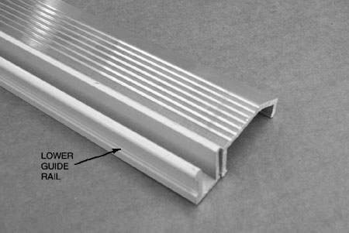
Standard Threshold

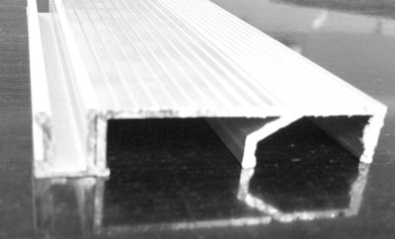
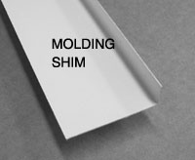
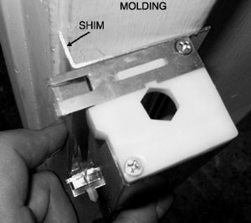
Flat Threshold- Shown between lower guide rail and the standard threshold (normally the customers existing threshold)

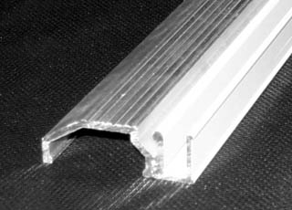
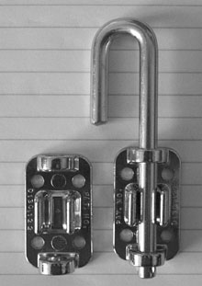
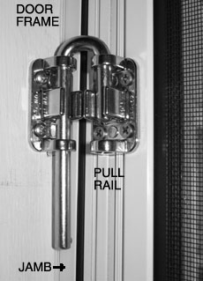
Front Threshold: has an interlocking ridge to add support to the lower guide rail.
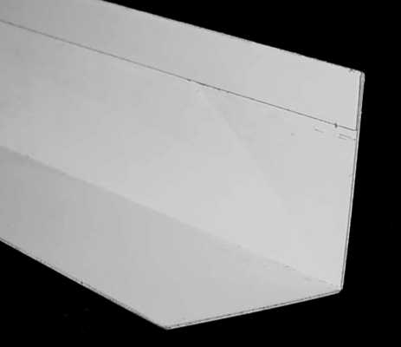
J-latch for single doors. Allows for a wide variety of installations.

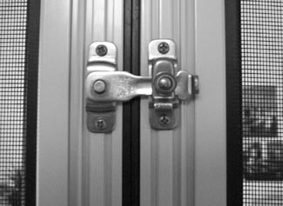
Double door latch. Stainless steel low profile.
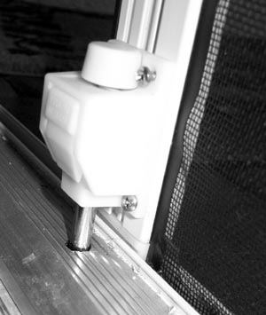
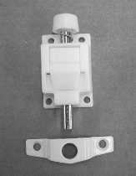
Double door stop pins(come as a pair). The pin on the right has been mounted with a hole directly in the threshold- the keeper plate was not used.

Molding shim for clamshell door molding. Long screws mount directly through shim.

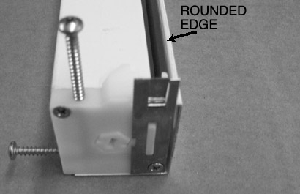
Housing back cover plate. Used when the fourth side of the housing is exposed to elements (blowing sand, volcanic ash, etc)

