INSTALLING THE TOP SEAL (Included with Standard Doors)

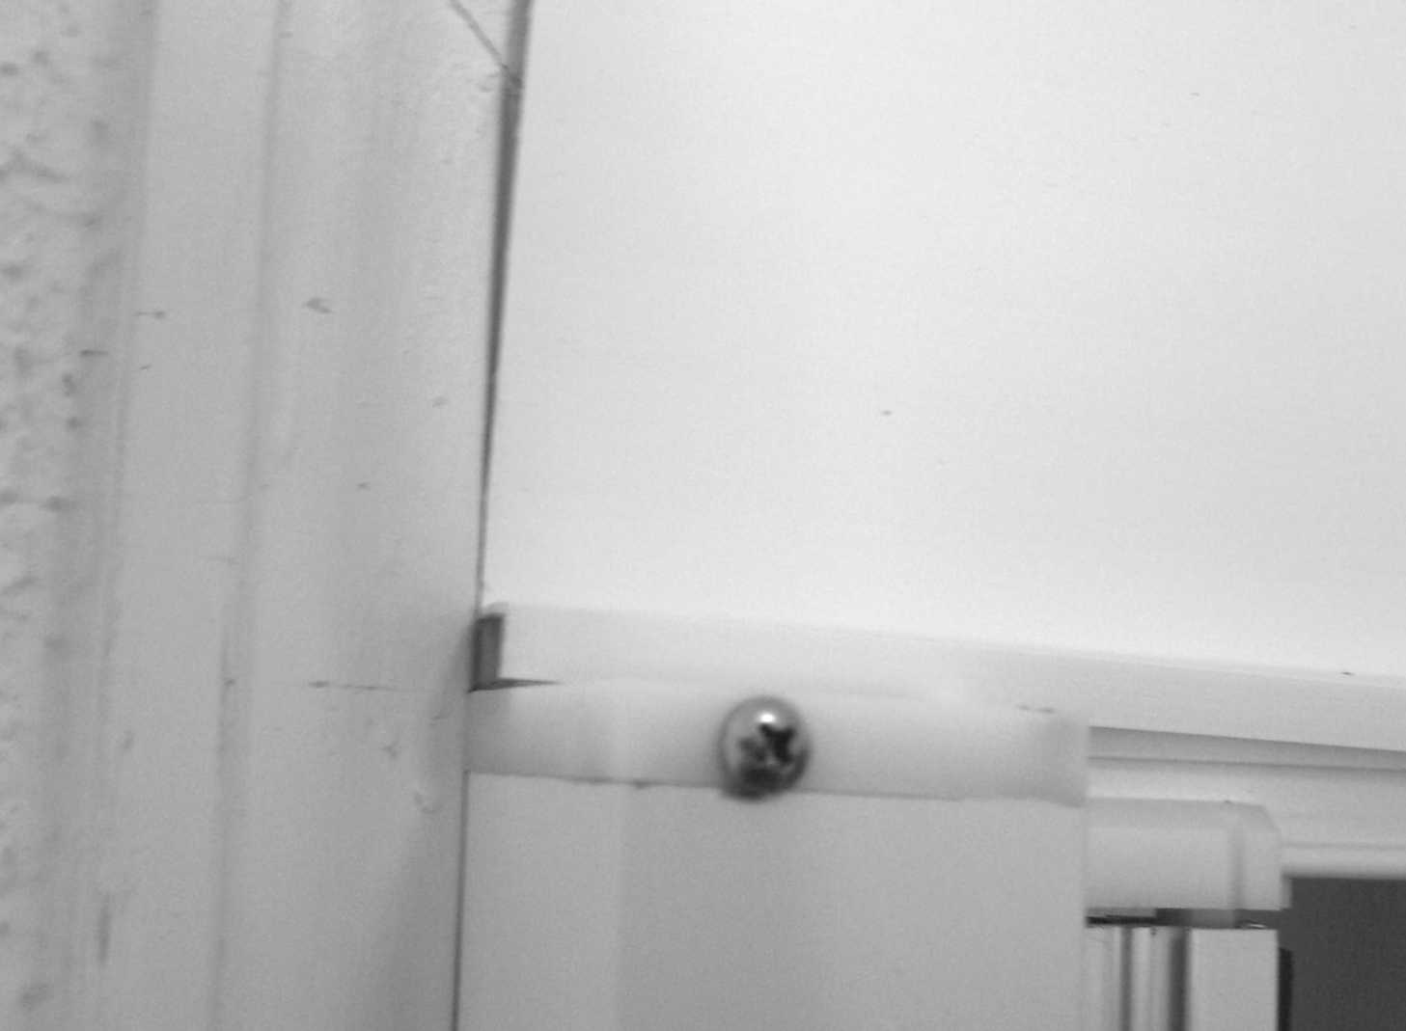
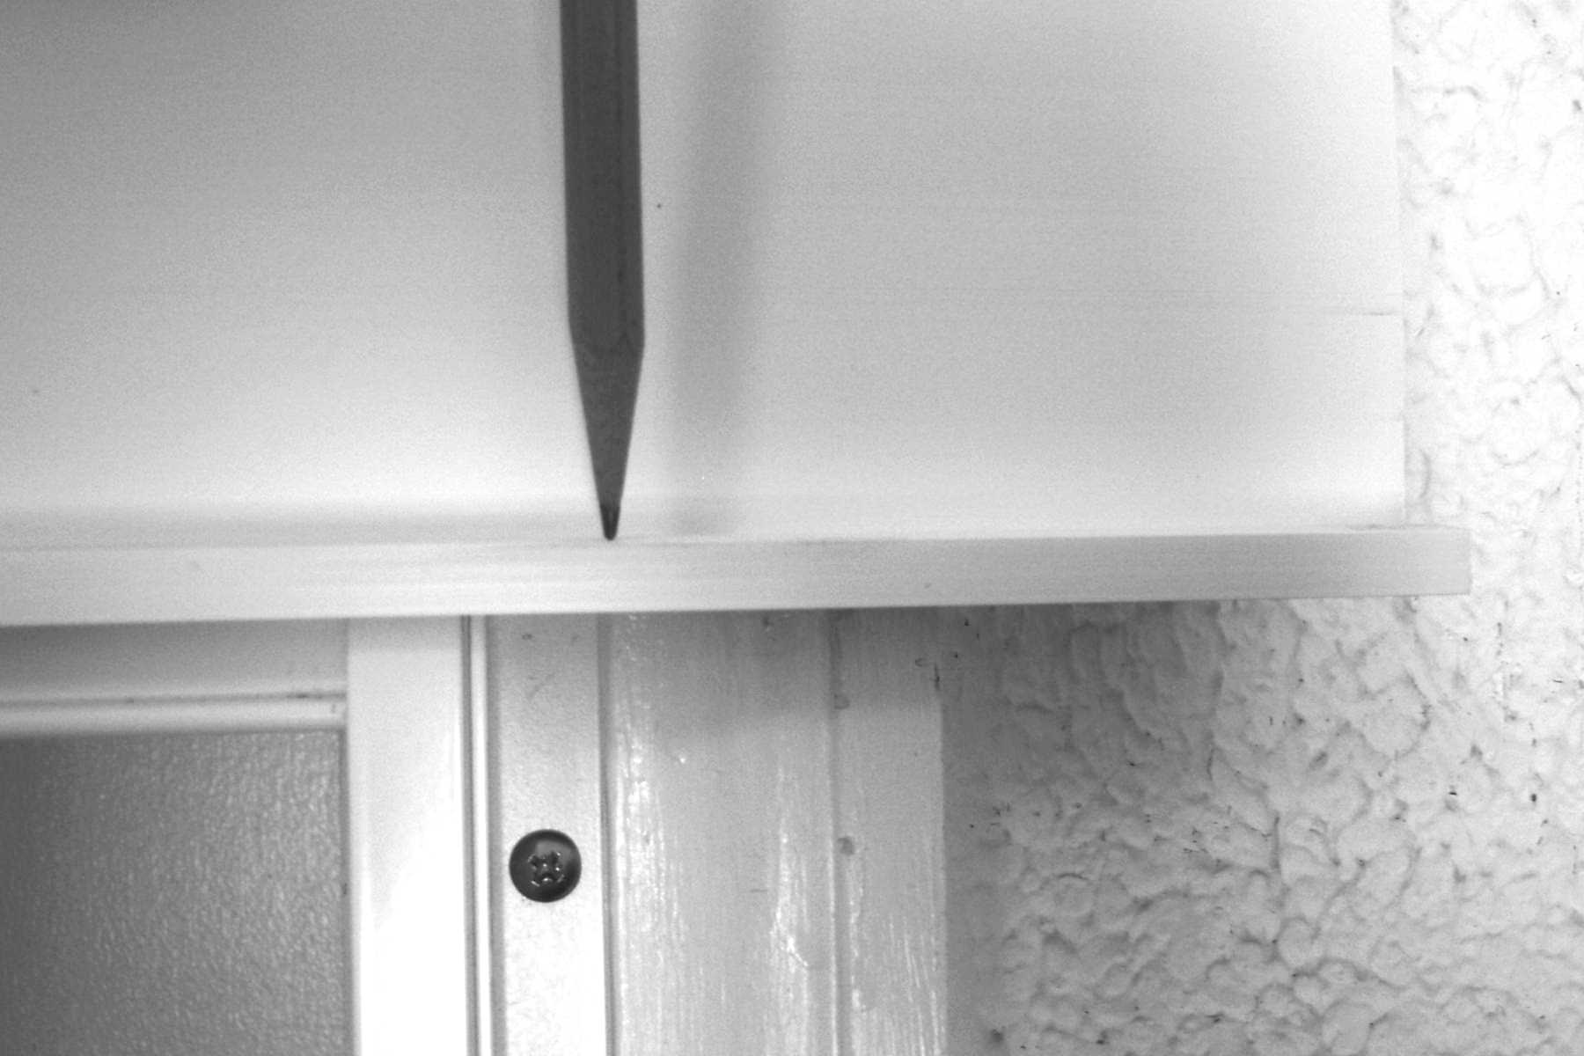
STEP 1: If your door came with a vinyl top seal and there is a gap between the upper guide rail and the top molding, use the color matched top seal to fill the gap. Mark the width of the door from the furthest edge of the housing to the furthest edge of the jamb assembly, and cut the top seal to this length using shears or a utility knife.
NOTE: For double door installations, all referrals to “jamb” apply to the second housing.

Fig 1 Measuring Top Seal width

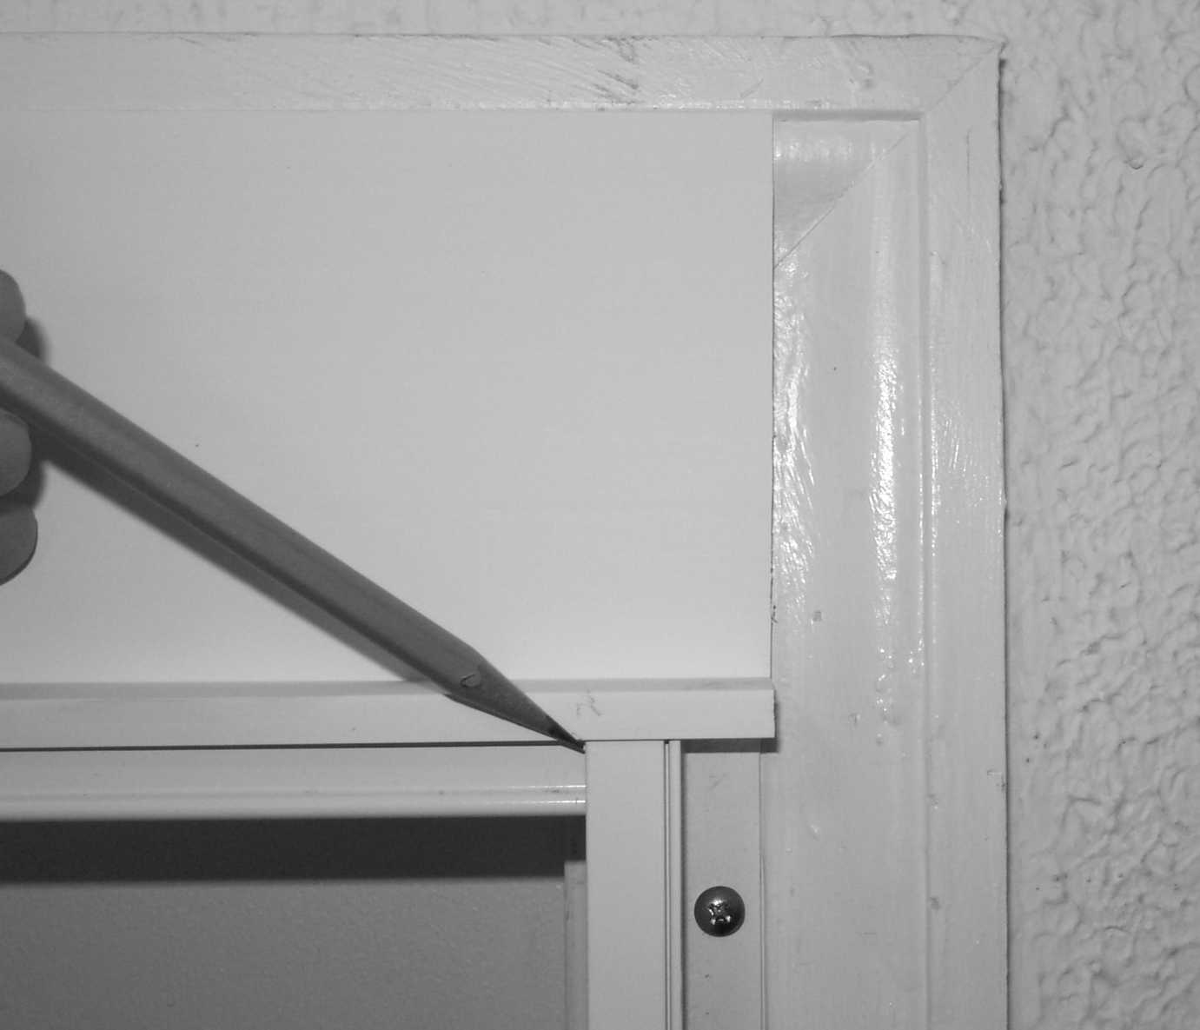
STEP 2: Mark notch points in the top seal for the housing and jamb. Set the top seal in position on top of the upper guide rail. Using a pencil, mark the edge of the housing and jamb with a pencil (Figure 2). Using sharp shears or a utility knife cut a notch the portions of the top seal which sit upon the housing and jamb where it was marked in step 9.
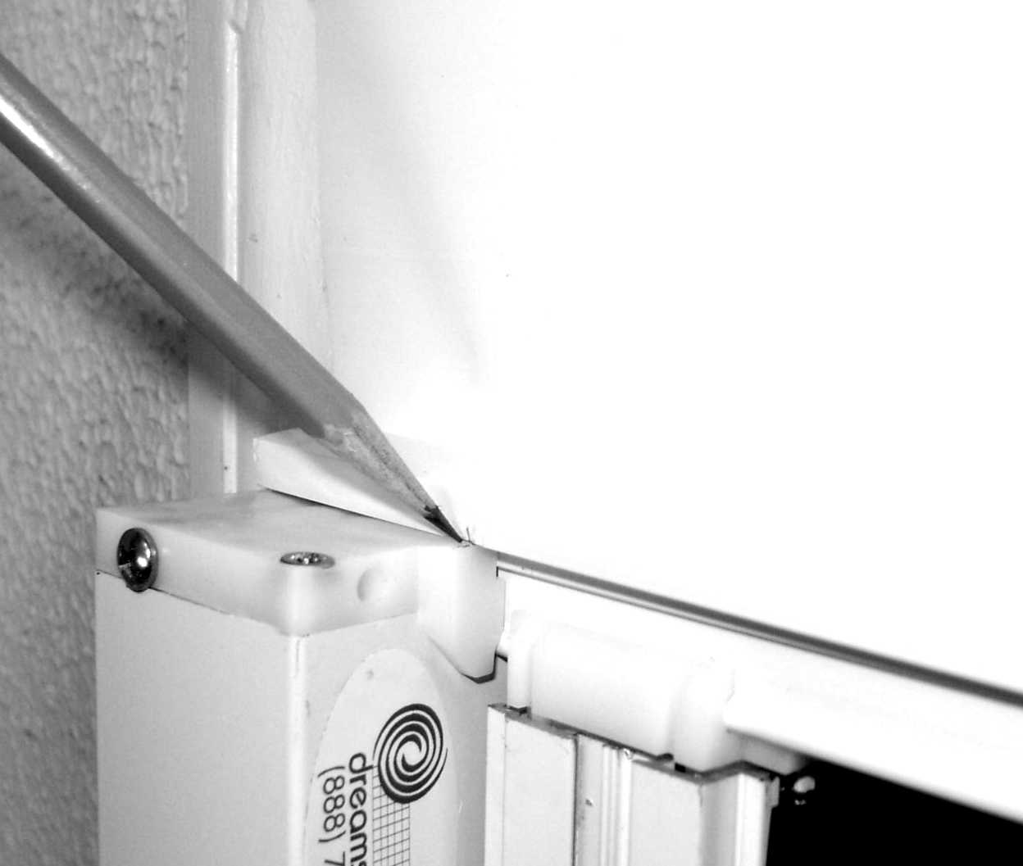
Fig 2 Measuring top seal trim points

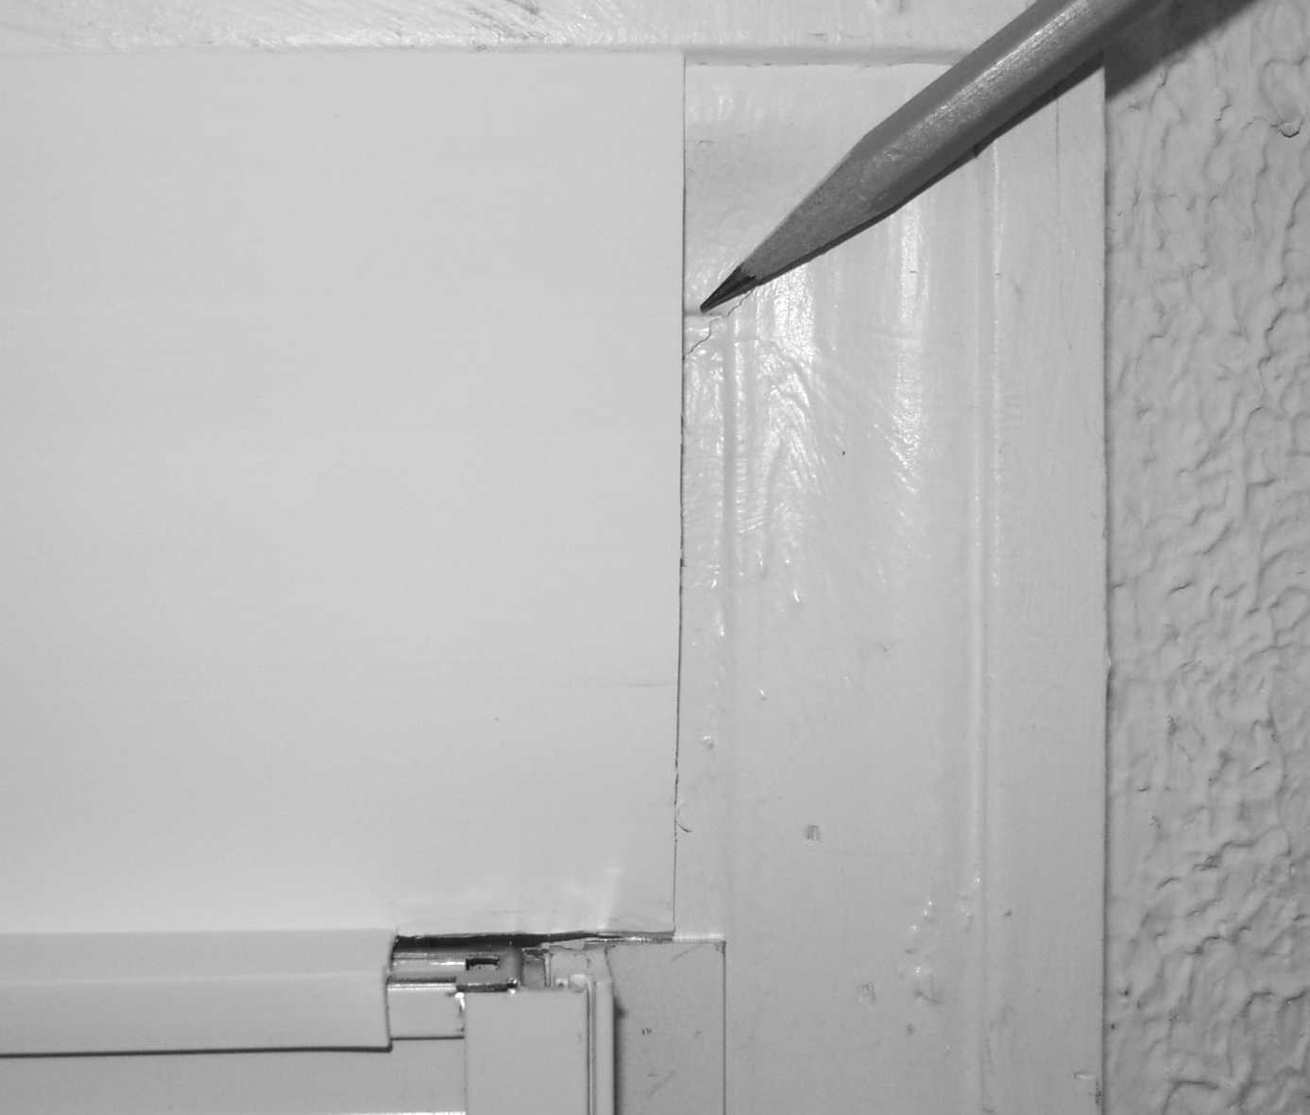
STEP 3: Cut the top seal height. Place the notched top seal in position; it should fit nicely around the housing and jamb. Mark the cut off height on the top seal at both ends of the top seal. If the door is out of square, the height will be different. Cut on a straight line between the two marks. For flush mounts, it may be difficult to place the top seal above the guide rail to get the height; if so, use a tape measure at both ends.
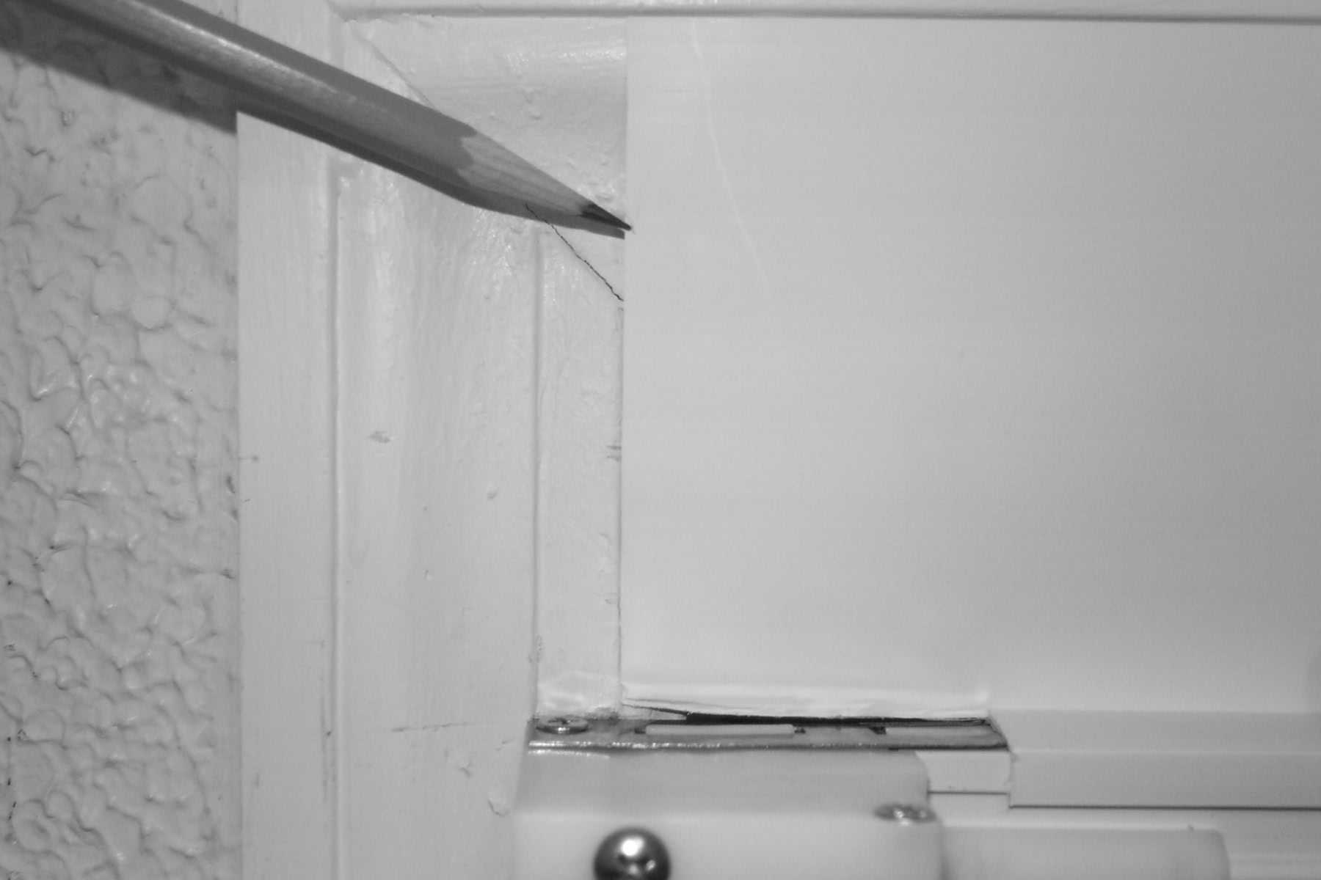
Fig 3 Marking top seal height

STEP 11: Mount the top seal. Remove the paper from the double backed tape and firmly apply the top seal to the upper guide rail. It is recommended that for a perfect finish, caulking be applied around the edges of the top seal as well as the housing and jamb.

TROUBLESHOOTING

- Drag or hesitation while opening or closing the door when it is new is almost always due to the guide rails not being parallel
- Drag or failure to close completely is usually due to dirty or sticky guide rail. Clean the rail, then apply a silicone lubricant. Lubrication is important.
- There is a normally some “waviness” in the screen surface with the door closed. If there is excessive waviness, it is likely that the door is not square or the guide rails are not parallel.
- If the jamb is not parallel to the housing, the screen will not retract evenly, ultimately causing the door to bind and fail to fully retract.
- A dent in either guide rail can cause drag or completely prevent the door from operating.

Occasional lubrication of the top and bottom guide rail with spray silicon will ensure smooth operation for years to come.

ADJUSTING SCREEN TENSION (Should NOT be required!)

Do not attempt to adjust tension unless there is very clearly a need to modify the factory setting. If there is any doubt whether adjusting is necessary, please contact your dealer or Dreamscreen for technical advice. See “troubleshooting” above before adjusting tension.

The tension adjusting wrench has been included for the RARE circumstance when the tension of the door needs to be increased or decreased. Improper technique while adjusting the tension will result in the complete unwinding of the spring and/or damage to the end cap.

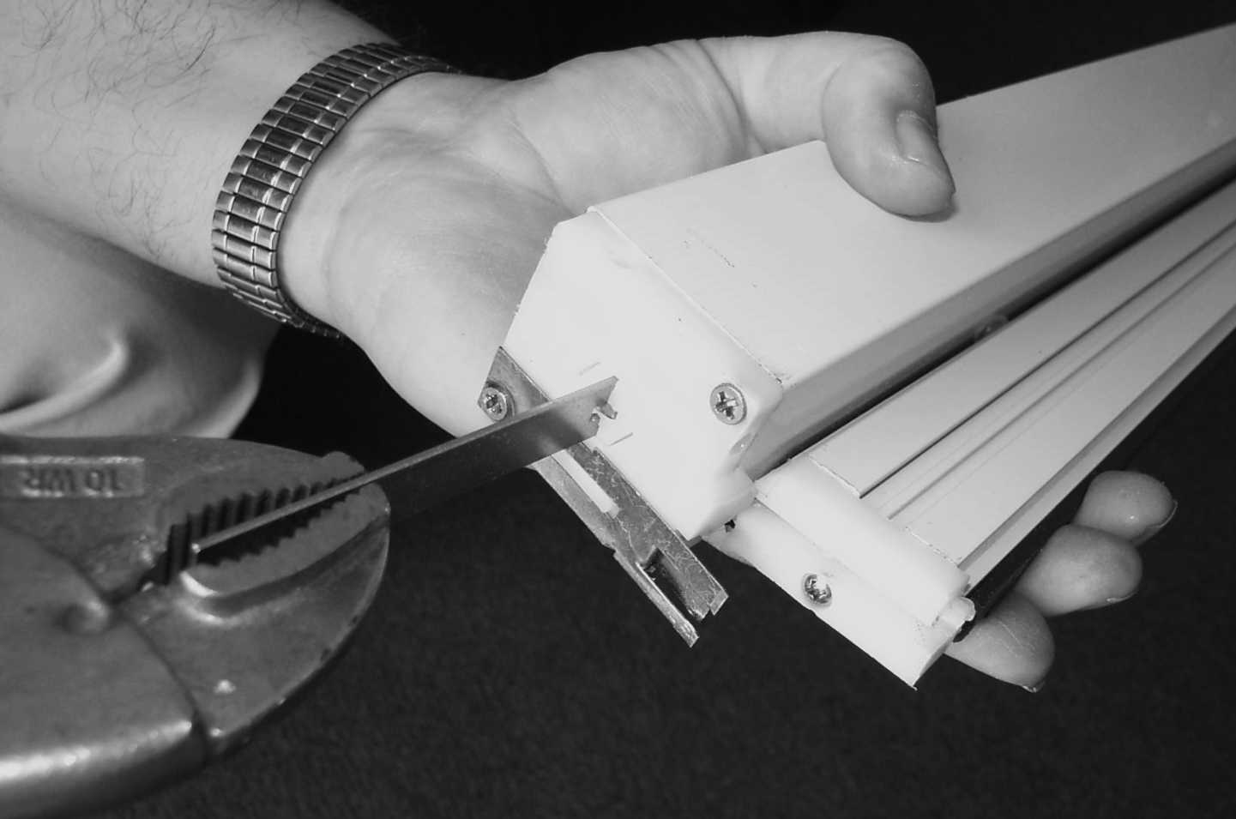
Generally, it’s best to adjust tension with the housing not mounted so that enough torque can be applied. To increase tension, insert the supplied tension adjusting wrench in the hexagonal bolt, push the bolt in about 1/8th of inch, and rotate clockwise. Failure to push could cause the hex to strip and permanently damage the door. Be careful not to let the wrench slip, or the spring will unwind. It is recommended that vice grip pliers be used with the wrench. One turn makes a significant difference in tension. To decrease tension, follow the same procedure, except turn counter-clockwise. From the factory, the Dreamscreen is wound with 24 clockwise turns for Right-Hand doors, and 24 counter-clockwise turn for left-Hand doors turns.
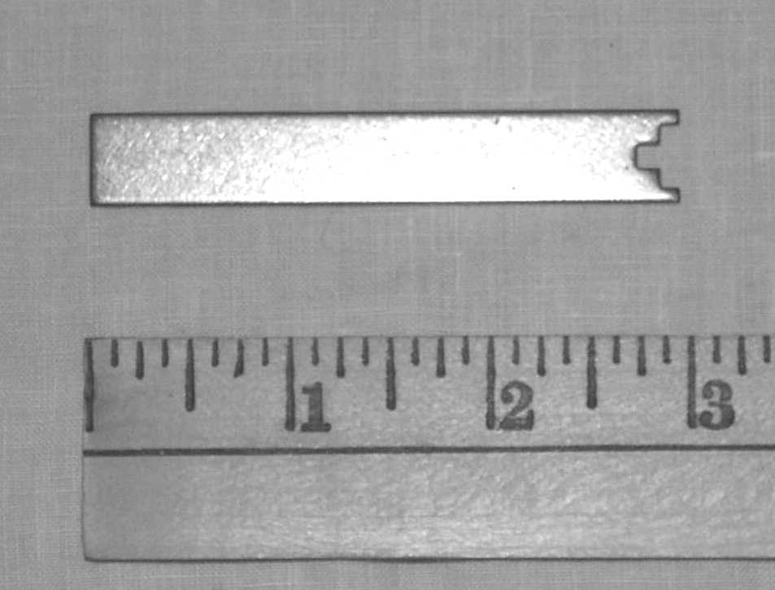
Tension adjusting wrench
Adjusting the tension (not recommended)

